Student: **Donagh Twomey - 10733479**

Subject: **Software Engineering Methods – CT871**

Date: **3rd November 2013**

Assignment: **Assignment 1 - HEALTHYU**

**Plagiarism Declaration:**

**I am aware of what plagiarism is and sign here to confirm that this work is my own:**

**­­­­­__________­­­­_____**

**Donagh Twomey**

**HealthyU : Stakeholders/Requirements**

**Stakeholders:**

Users

* *Current members*
* *Potential members*
* *Management employees*

Developers

* Software programmers
* Database designers
* Domain experts (Software/Healthcare/Quality specialists)
* Testers
* Software system maintenance team
* Stockholders

Decision Makers

* Client (Executive paying for system development)
* Supervisors

**Gathering Requirements:**

*The initial step in developing a functional system for HealthyU is to first fully elicit the aims of the club and encompass all activities of the system.*

HealthyU Aims

* To replace their current regional system with a centralised system to automatically generate renewal notifications for members with memberships due for expiry
* To create and display an automatic subscription package for potential new members based on currently set membership offers and current special offers
* To allow management to view members’ usage of the club in order to offer (and manually apply) potential discounts on renewal offers
* To allow members to accept and pay for accepted subscriptions online and to generate new (or update current) entry for new member in the database
* Upon registration the system will request and store data on goal attainment which will be stored with the customer details (listed in assumptions)
* To allow members to access the system in order to update their goal attainment as well as viewing their actual usage of the club
* To investigate the possibility of including some innovative technology (eg phone app) that will allow user to keep track of their health goals
* For management to be automatically sent a members’ renewal offer and their actual usage (including dates of usage) so as to update and confirm a renewal offer
* For the confirmed renewal offer to be sent automatically to the member (listed in assumptions)
* For some authority to be able to update membership and special offer prices (assumption that this will also fall to management)

Requirements Elicitation

*Initial steps in the requirements elicitation should be to identify potential pitfalls in the actual implementation of the system. The first step should be to approach domain experts and other clubs who have implemented similar systems, and through meetings or questionnaires attempt to identify and remove these pitfalls.*

*Clients and management should be regularly approached and confirm decisions on each step of the process design. ‘Who’ and ‘how’ (as opposed to ‘what’) each process is performed should regularly be discussed and confirmed. This should be a dynamic process. Regular negotiation with the client should be maintained. Using a spiral method of data gathering the client should regularly be updated and presented the opportunity to instigate changes. They should also be presented with prototypes to confirm the system is continuing to be developed in the direction the client wants.*

*Differing opinions on functionality from the client (depending on regional concerns) also needs to be considered. As the client is requesting a centralized system all regional or unique concerns need to be addressed in order to provide a generic system. It could be considered to have one of the software development stakeholders to ‘shadow’ normal daily operations of the club so as to ascertain individual concerns and have them addressed. This procedure should be performed early in the requirements elicitation phase (possibly before initial interviews with the client and management).*

*A questionnaire should be drafted and sent out to all current members’ of the club to attempt to identify any extra functionality of the system that would further improve performance of the system and satisfaction for the members. This process should also be performed with the employees of the club and all results should be collated and discussed with the client and management.*

*Security concerns also need to be addressed. As the system will store payment details of the members (listed in assumptions) domain experts need to explore the best way to keep member’s details secure. This could be done by data-mining or approaching other sites with similar procedures.*

*The possibility of the business environment in which the elicitation process takes place may change would also need to be taken into account. Attempts should be made to allow for the system to be manipulated in order to fulfil future changing needs by the software maintenance team.*





`





**HealthyU : Event List**

Process 1 (User New/Renew Membership)

1. *Flow:* User accesses/submits registration form

*Response:* System provides info on memberships/special offers. Allows renewal members to update current details

1. *Flow:* User provides payment details for chosen membership/special offers

*Response:* System uses external authorisation to confirm payment and updates member status to paid/unpaid

1. *Flow:* Management can update current members renewal offer if requested

Process 2 (Renewal Notifications)

1. *Flow:* Upcoming membership expiry generates automatic renewal with current special offers and based on members current membership subscription.

*Response1:* Users usage information taken from database and forwarded to management

*Response2:* Renewal offer forwarded to management

1. *Flow:* Management checks renewal, updates if required (eg prior usage falls within discount parameters).

*Response:* Updated renewal offers sent back to process

1. *Flow:* Final renewal offer (updated offer) forwarded to user (eg email address)

Process 3 (Club Usage Maintenance)

1. *Flow:* Member scans membership card upon entering club

*Response:* System records visit, increments club visits database and records date and duration of visit

1. *Flow:* Logged-in member (From P4 Login) updates goal attainment.

*Response:* Updated goals stored to user details database

1. *Flow:* Management requests member visit report

*Response:* System forwards visit info reports from database

Process 4 (Member Login)

1. *Flow:* User requests log in to access goals data

*Response:* System checks user details against member details (stored in D1 Member Details) and allows access to process 3 (Club Usage Maintenance) upon confirmation

*Should the client require app functionality, this process could be linked to the app and follow the same guidelines. The app would only allow access to updating user goals.*

Process 5 (Update System)

1. *Flow:* Management requests to add/delete/update membership/special offers

*Response:* System updates and stores new membership/special offer details

1. *Flow:* Management requests to add/delete/update member details

*Response:* System updates and stores member details



**HEALTHU: Manager Interface**

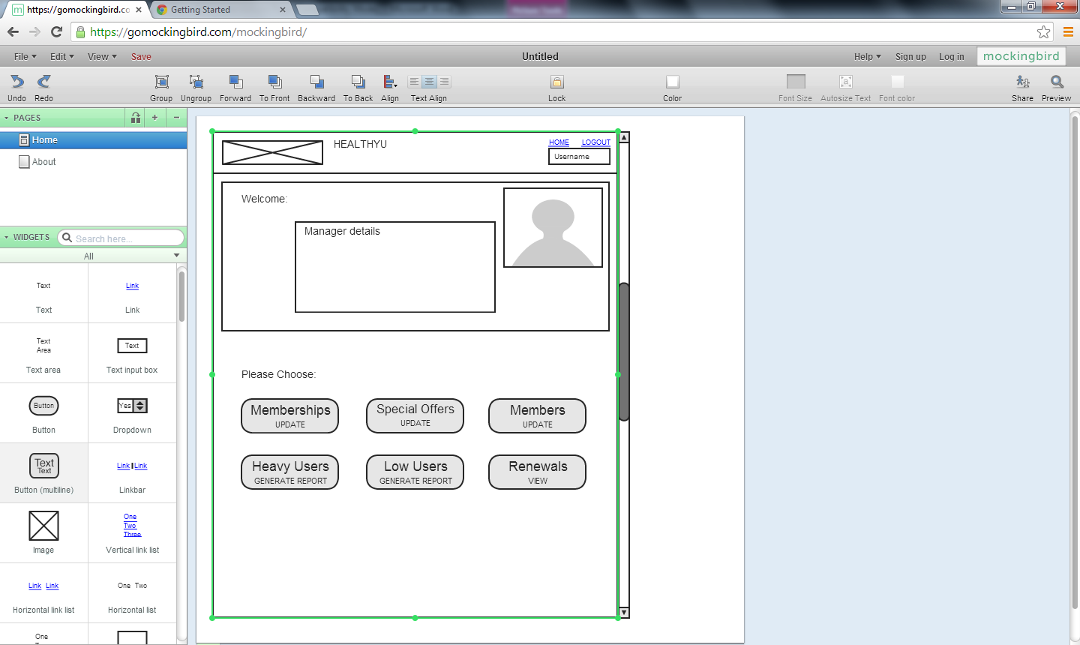

**HEALTHYU : User Interface**

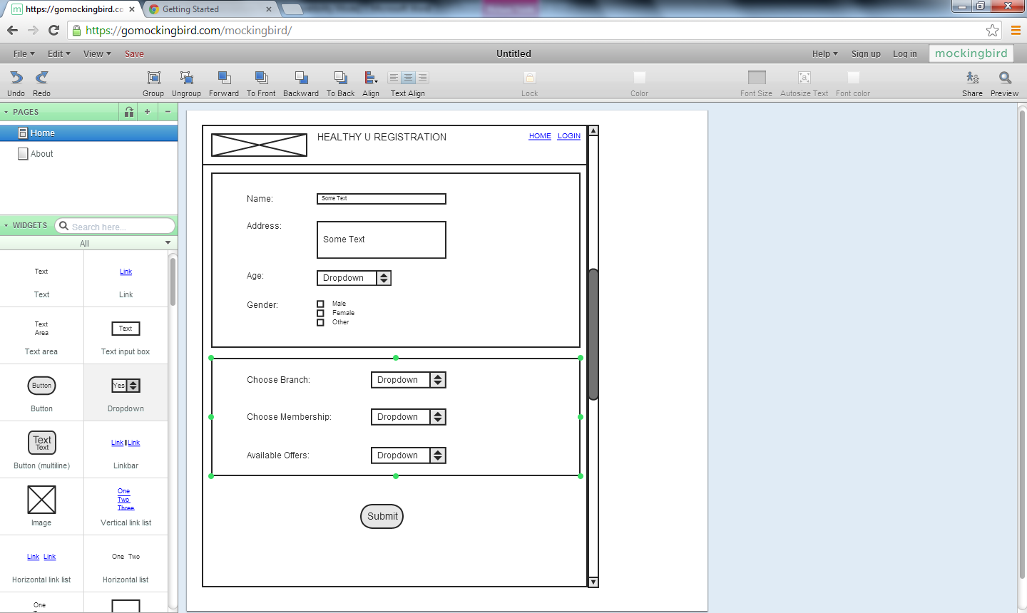

**HealthyU : Assumptions**

* The system will automatically generate renewals
* The system will automatically forward every member renewal offer and usage report to the management team for confirmation
* Renewals will automatically be emailed to the member upon confirmation
* The system does not include any procedure for posting renewals
* Manual updates to renewal offers can only be applied during the new/renew process
* Upon registration (new/renew process) the system will request and store data on goal attainment which will be stored with the customer details
* Management will be assigned the duties of updating membership and special offer prices
* Payment details will be stored on the database with user details and confirmed by and external authorisation
* Club visit details are read-only for members and management. This process can only be updated by the physical process of scanning in member card upon passing reception of the club
* To address privacy concerns, management can read the club visit info on members but do not have access to the members goal attainment data (stored in separate table)

**HealthyU : Innovative Technology**

*As the system has been designed in such a way that details of members’ goal attainment is stored in a separate table, it is conceivable that a mobile app could be created that allows a user to login and update personal goal attainment data from a personal device. This would require an app that would check entered details in the app against saved member details and upon confirmation, allow the user to update their goals and store this data back to the relevant table. This could be achieved through creating the app and connecting to the database via PHP script, without causing excessive disturbance to the functioning of the system itself.*

*An app could be designed in a very simplistic fashion:*

**Step 1:** Sign-in (Checks and confirms details on system database)

**Step 2:** Give member option to update sessions attended, current weight etc.

**Step 3:** Store updated information back to database and exit

Example of Display



*Further investigation would need to be carried out with members and domain experts to ascertain what specific functionality (e.g. choices) the members’ would require on the app.*